**REPORT**

Zajęcia: Analog and digital electronic circuits

Teacher: prof. dr hab. Vasyl Martsenyuk

**Lab 1**

28.03.2025

**Topic:** "Spectral Analysis of Deterministic Signals"

**Variant: 13**

Rafał Żmuda

Informatyka II stopień,

stacjonarne,

1 semestr,

Gr.2b

1. **Problem statement:**

The task is to simulate two random signals with different power levels, analyze their statistical properties (mean and variance), and estimate their Power Spectral Densities (PSDs) using Welch's method with Hamming and Hann windows. The goal is to compare the energy, standard deviation, and spectral characteristics of the two signals.

1. **Commands used (or GUI):**
2. source code for random signal generation

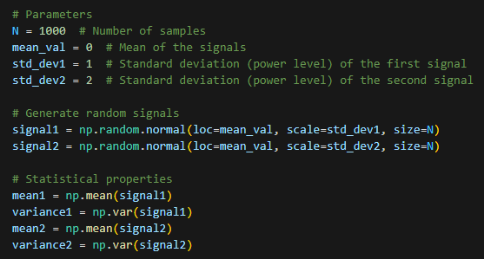

1. source code for getting power spectrum values

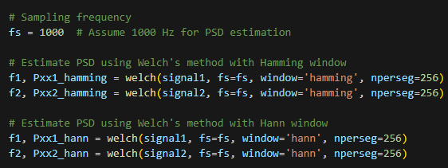

Link to remote repository: https://github.com/RafalZmu/School/Lab%205

1. **Outcomes:**

Outcome for the random signal generation

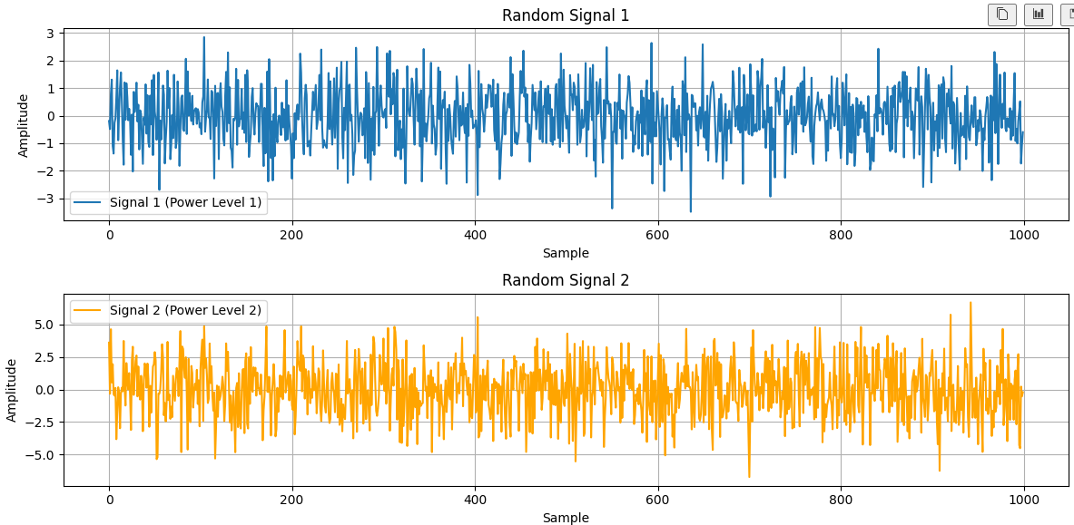

Outcome for Power Spectral Density

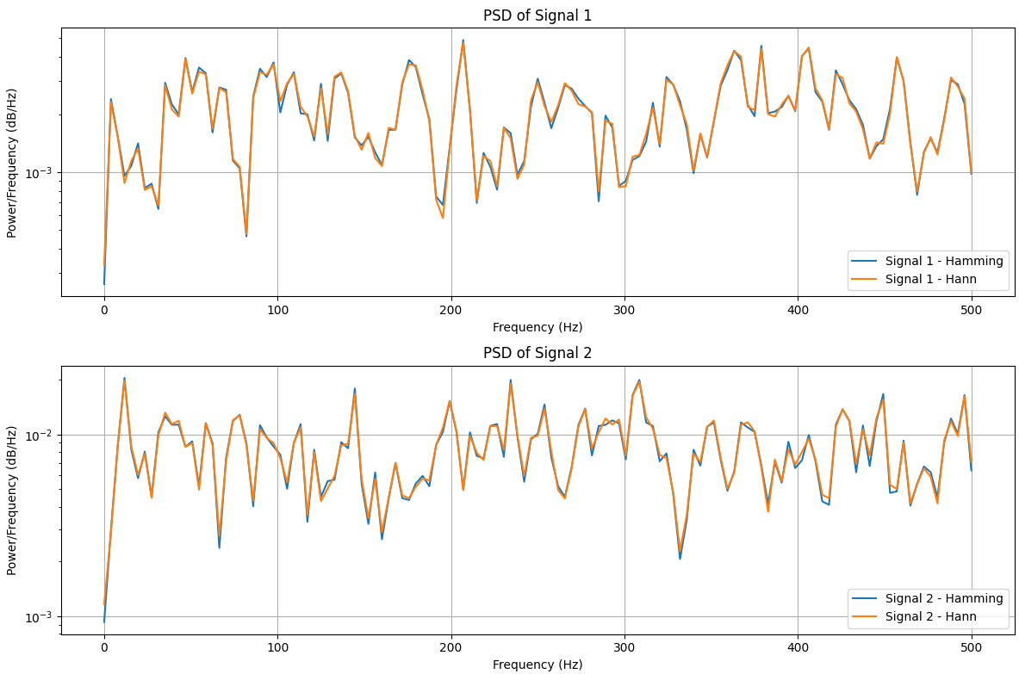

**5. Conclusions:**

The simulation successfully demonstrates the generation of two random signals with different power levels, their statistical analysis, and spectral characterization using Welch's method. The results highlight the relationship between signal variance and power, as well as the effect of different windowing techniques on PSD estimation.